Fog Classification System
0 – Dark | 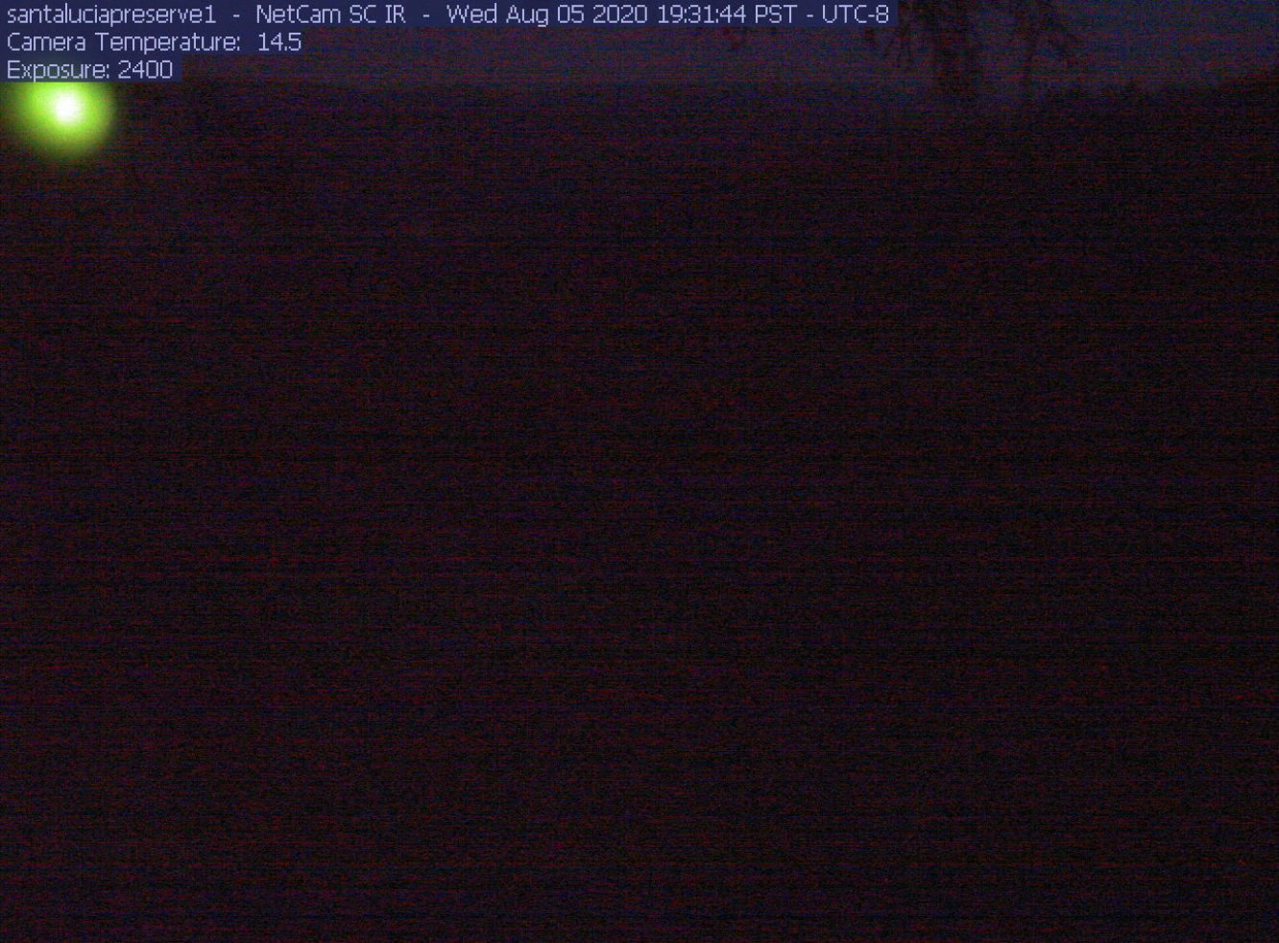
1 – Clear Day | 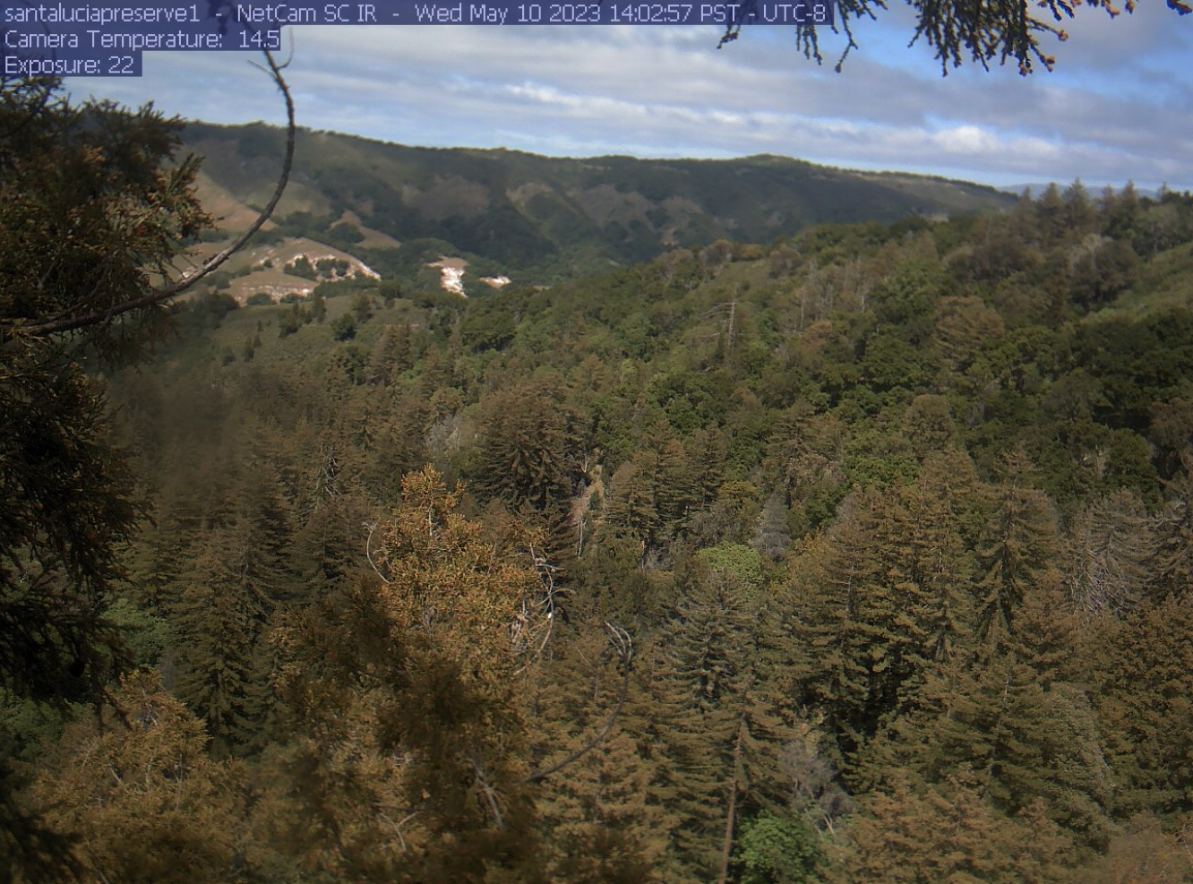
2 – Light Fog in Background, Clear in Midground and Foreground | 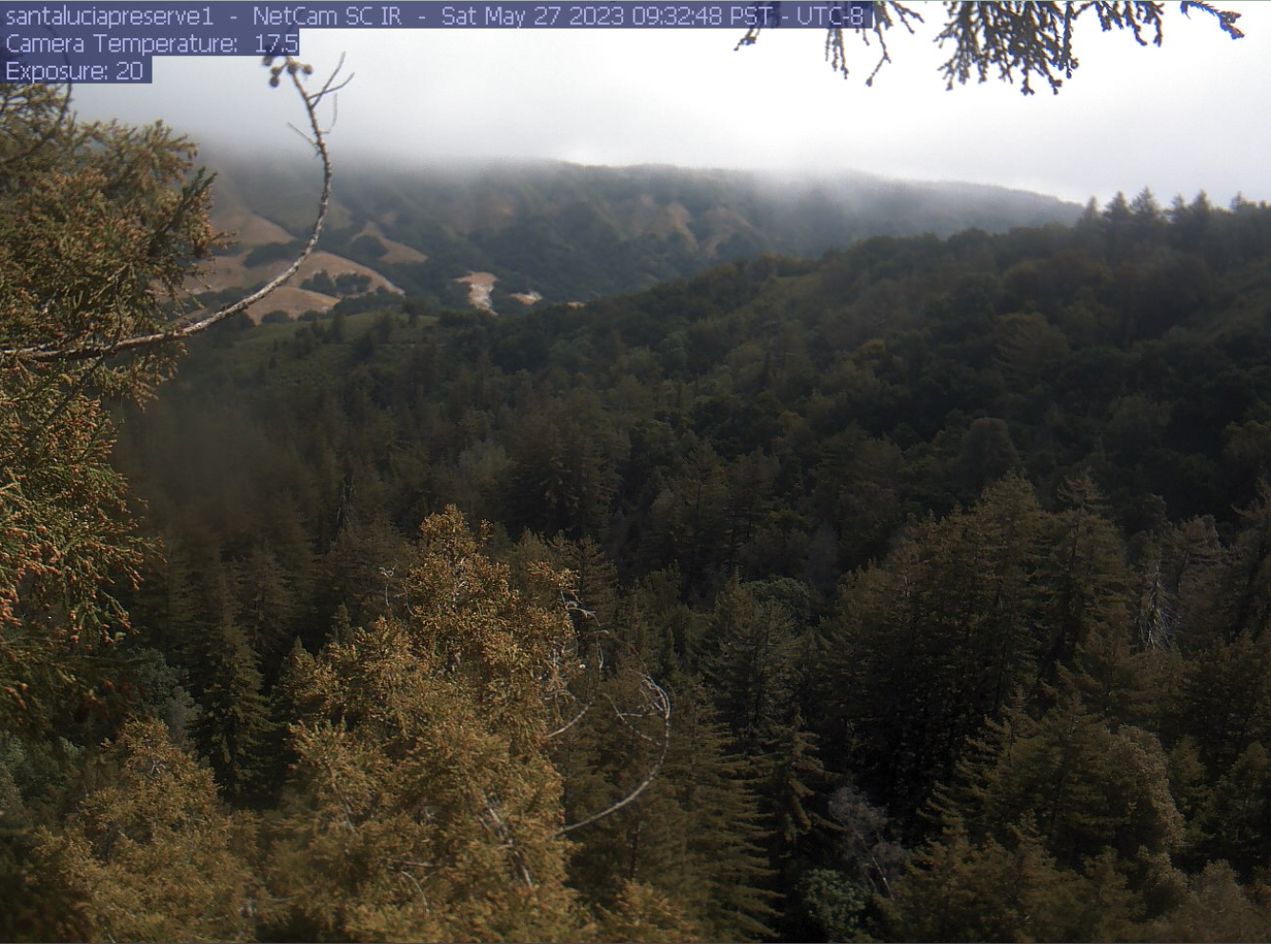
3 – Heavy Fog in Background, Clear in Midground and Foreground | 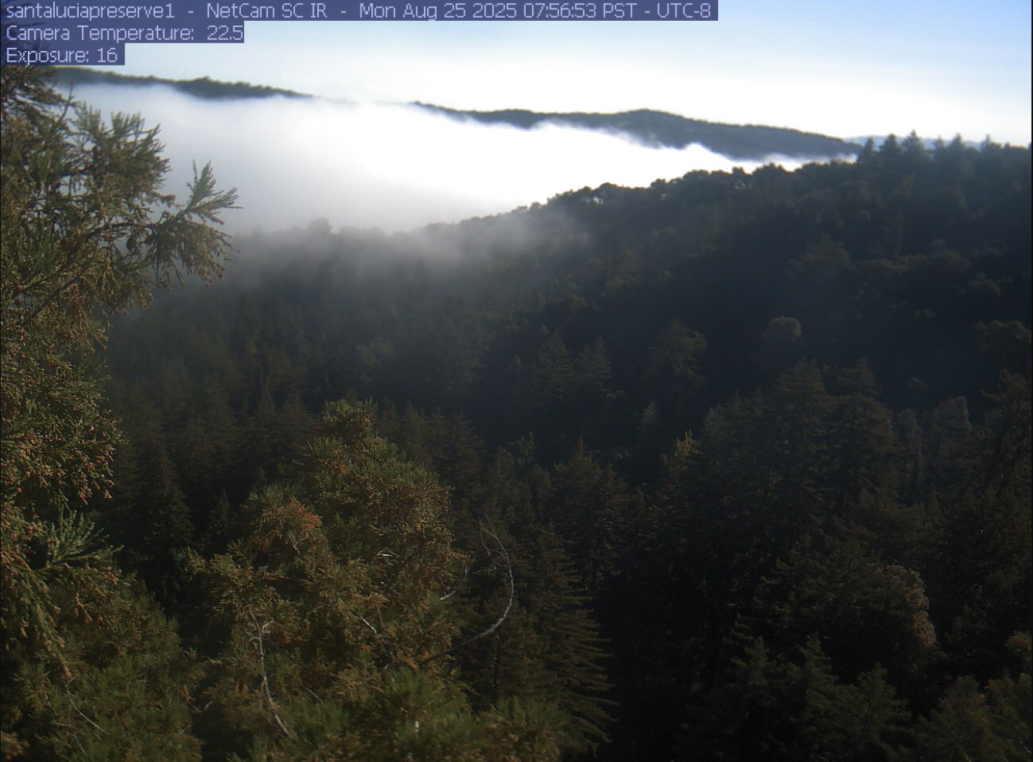
4 – Heavy Fog in Background, Light Fog in Midground, Clear in Foreground | 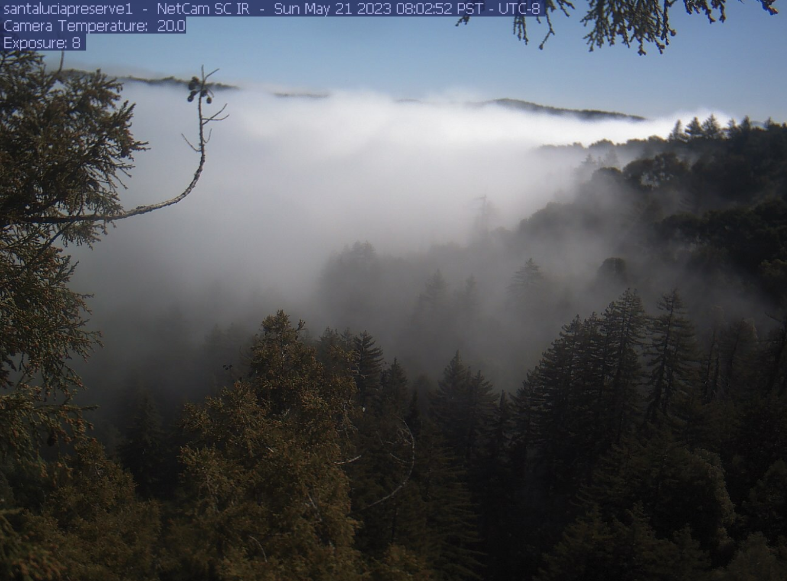
5 – Heavy Fog in Background and Midground, Clear in Foreground | 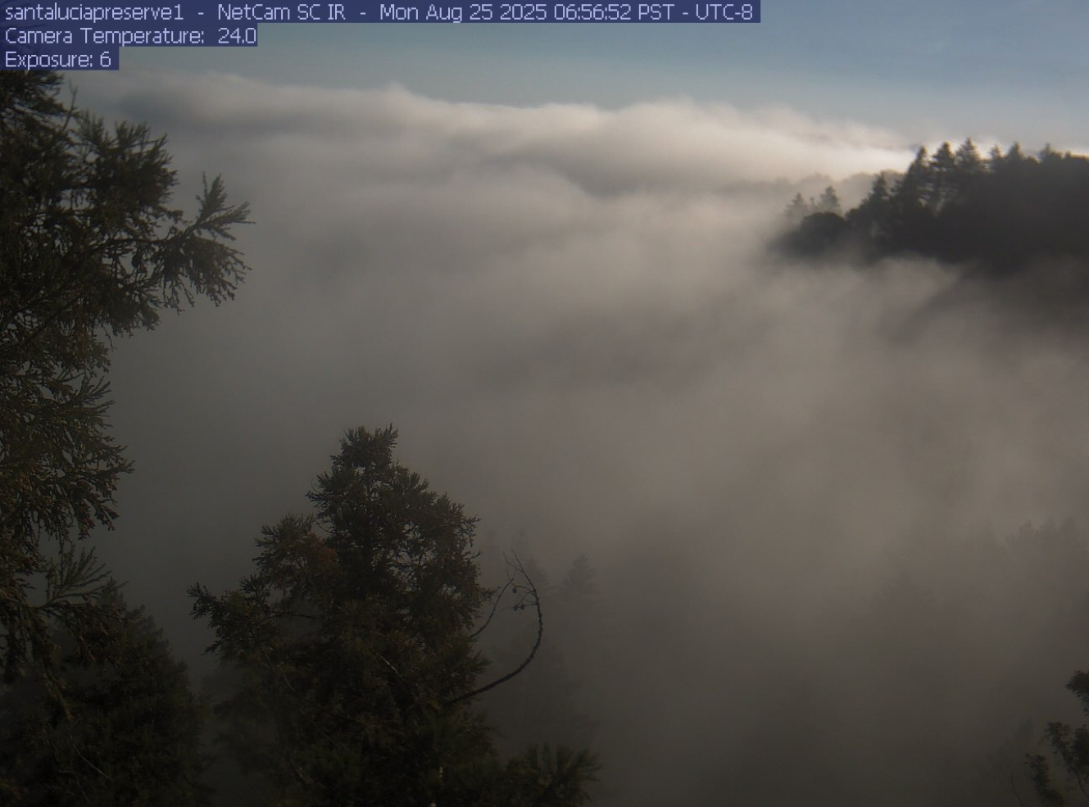
6 – Heavy Fog in Background and Midground, Light Fog in Foreground | 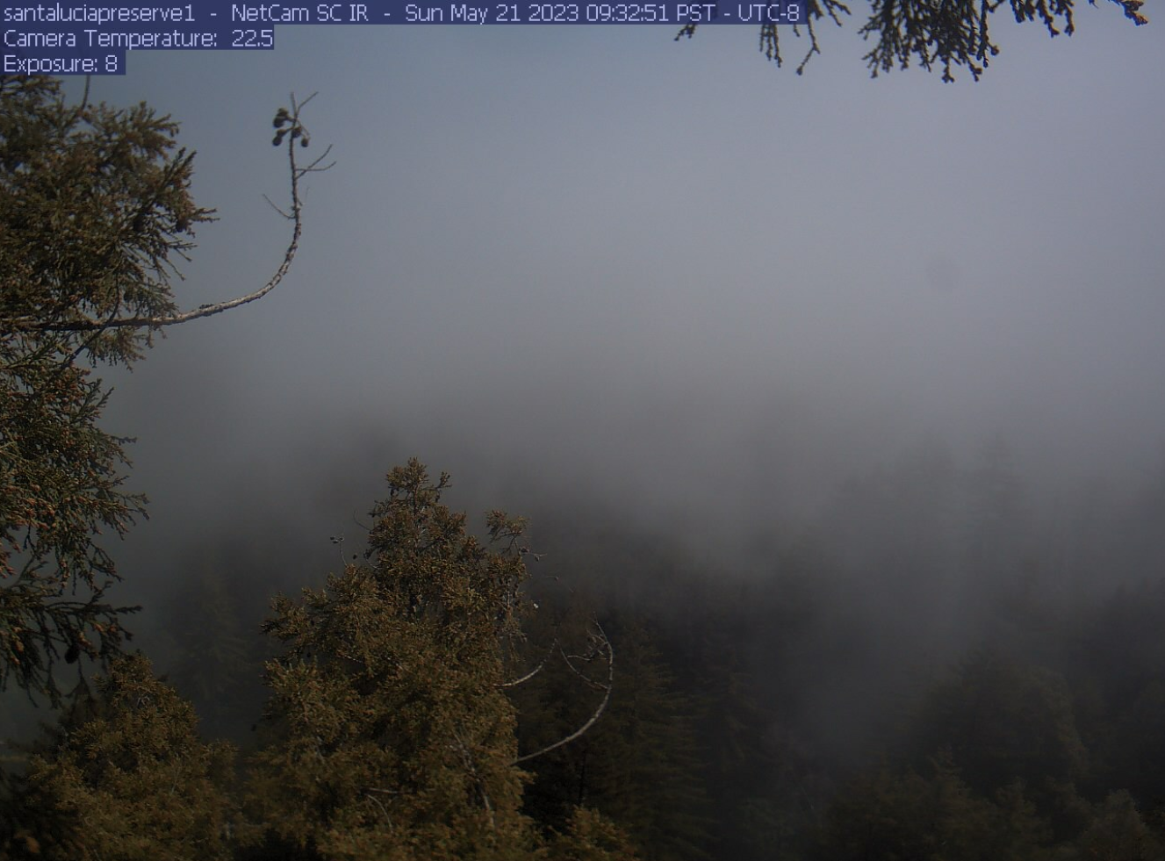
7 – Heavy Fog in Background, Midground, and Foreground | 